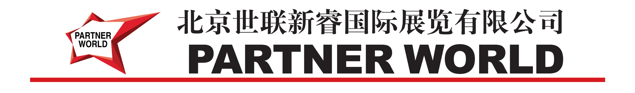
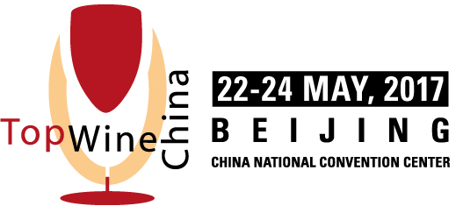

Beijing, Aug, 22, 2016

Dear

We are pleased to send you this official letter for inviting you as an exhibitor to participate in TOPWINE CHINA 2017.

The Exhibition of Sponsored and organized by
China National Association for Foreign Trade and Economic Cooperation
B.V. Industrial Promotions International
Beijing Partnerworld International Exhibition Co., Ltd

This exhibition will take place in Beijing, China at Beijing Expo - China National Convention Center from Monday 22th May to Wednesday 24th May, 2017.

The general schedule is as follows:
May 21th: Setting up the booth and arranging the exhibition affairs
May 22th to May24th: Attending the exhibition
May 25th to May 26th: Move out the booth
May 27th:Departure from Beijing

This official invitation concerns:

Company Name
Company Address
Name:
Sex:
Nationality:
Passport number:
Date of issue:
Date of expiry:
Date of birth:

Please note that all costs related to your visit shall be arranged and paid by yourself.

We look forward to meeting you at the show on May, and remain at your disposal for any further information.

Yours Sincerely,

Minli Sun
PR Manager
Beijing Partnerworld International Exhibition Co.,Ltd
Address: Rm 221, 2nd Floor, MOMA Tower,
No. 199 Chao Yang Bei Road, Chaoyang District, Beijing, China 100026
Tel: +86 10 59429608
Fax: +86 10 64066518
Email: marketing@topwinechina.cn

